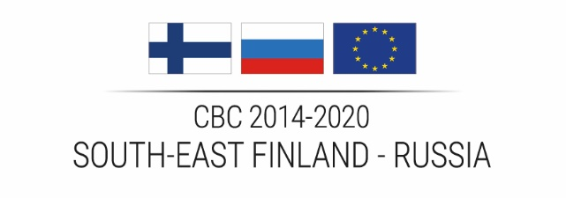

ERV6
Report on suspected and/or established fraud
of a Grant Contract financed by
the South-East Finland - Russia CBC 2014-2020 Programme

Addressed to:

South-East Finland – Russia CBC 2014-2020 Programme
Programme Director
Regional Council of South Karelia
Cross-Border Cooperation unit
Kauppakatu 40 D, 1. floor,
53100 Lappeenranta FINLAND

NOTE
The Auditor shall send report on suspected and/or established fraud directly to the Managing Authority, without any need of informing
the concerned beneficiary.

IDENTIFICATION FICHE

Name of the project | <type here the full name of the project>
Project acronym | <type here the acronym of the project>
Project ID | <type here the project id>

BENEFICIARY
Organisation legal name | <type here the official legal name of the organisation>
Postal address | <type here the official postal address of the organisation>
Country | <type here the country of the organisation>
Registration number or Business ID | <type here the registration number of business id of the organisation>

I hereby inform the Managing Authority of the South-East Finland – Russia CBC 2014-2020 Programme that, based on the provided documents, on my verification and my professional judgement as, I have become aware [and/or] found evidence of suspected fraud [and/or] established fraud for the above-mentioned project beneficiary.

- Typology of fraud
Please explain in detail the nature of suspected and/or established fraud that you wish to inform the Programme.

- Scope of expenditure concerned by the fraud
Concerned beneficiary report(s) from period
Concerned budget line(s)
Identification of specific contracts and expenditure items concerned
Amount of expenditure concerned (in EUR and local currency)

- Basis for suspected and/or established fraud
Please explain in detail the reasons/circumstances leading you to suspect the existence of fraud or to report established fraud for this specific project beneficiary (i.e. Why do you think there may be fraud? / How did you become aware of the suspected/established fraud?).
Please provide some concrete facts about the suspicion of fraud or the details of the established fraud (including reference of the competent authority/court decision for established fraud)
Please indicate the actions you already undertook to analyse the specific case in-depth.
Please also specify if you reported this suspected or established fraud to any other competent authority and if any administrative or judicial proceedings in relation to this case has been initiated.

- Potential impact of the suspected or established fraud outside the ENI CBC project
If applicable, please list other EU co-funded programmes and projects in which the same beneficiary is involved (to your knowledge)
Please add any complementary indication you deem useful to identify and limit the impact of the suspected or established fraud

I hereby declare that my assessment is based on actual evidence that I have seen during my verification of the expenditure claim.

I am aware that the Managing Authority and the European and national competent bodies may use this evidence to undertake further investigations, which could lead to appropriate administrative and/or legal actions in relation to suspected unlawful activity.

Yours sincerely,
Date and place: <type here place and date>

Auditor’s signature <person/firm, as appropriate and in accordance with the company policy>

Name of Auditor signing: <type here the name>

